1. **Formulation $(3.4)$, Page $28$:**

A little confusing, I think the following general equation for the rigid body kinetic will help to illustrate:

$$\frac{\text{d}r_{m}}{\text{d}t}=\frac{\text{d}r_{A}}{\text{d}t}+\frac{\text{d}r_{m}^{'}}{\text{d}t}=V_{A}+ω×r_{m}^{'}$$

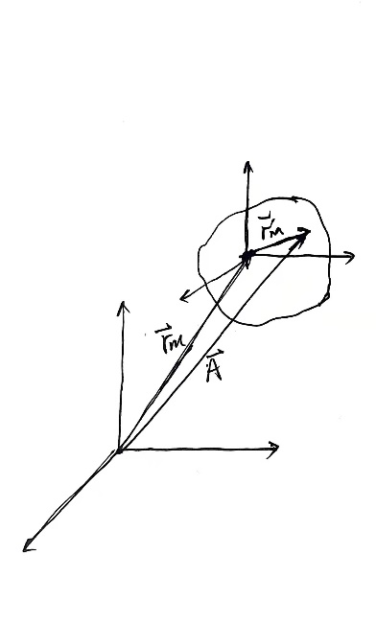

1. **Figure 4.1 Page 32:**

A little problem about the “Red axis”, which should be (1,0,0) I think.

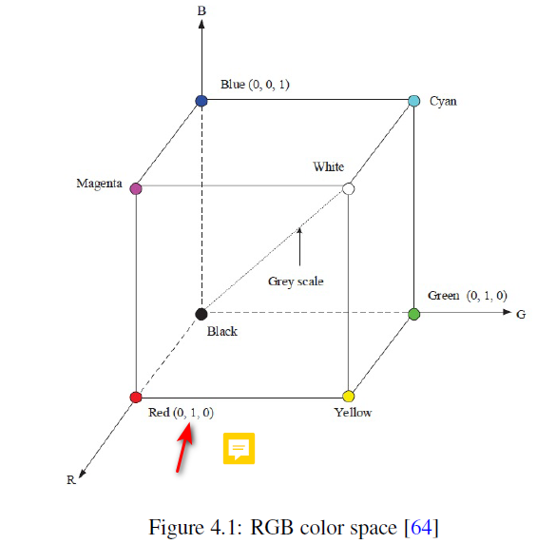

1. **Formulation $(4.10)$, Page $59$:**

The vector ${ [x,y,1]}^{T}$ on the right side has undefined elements $x, y$.

1. **Page $65$:**

I think the relationship between the guidance law and the 2-DOF Frame control law should be illustrated when talking “mount this system on a UAV and test it there” in Chapter 5. It’s like the “bridge” between the 2-DOF Platform and the UAV.

I am not familiar with the computer vision field but I think the "threshold thing" in this paper is not that hard actually. And I really learn the color space from this paper!

For the vision part, I am not familiar with the computer vision field but I think the "threshold thing" in this paper is ready to apply with high efficiency. And I really learn the color space from this paper!

点火源，不是火的范围，这个如何估计？